**Data Management Plan (Iteration 2)**

**Donor:** DonorID (unique identifier) Name Contact Information Blood Type Donation History Health Records

**Patient:** PatientID (unique identifier) Name Contact Information Medical History Blood Type

**Admin:** AdminID (unique identifier) Name Contact Information Role/Permissions

**Blood Bank:** BloodBankID (unique identifier) Name Location Blood Inventory

**Request:** RequestID (unique identifier) Requester (either Donor or Patient) Blood Type Requested Quantity Date and Time Status (e.g., pending, fulfilled)

**ER diagram:** 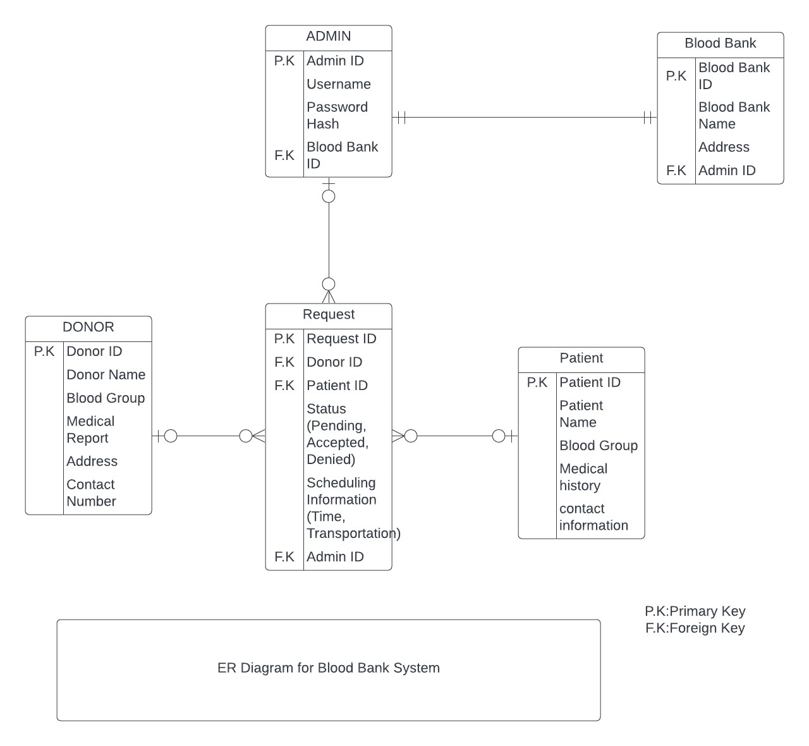

**Initial Data Security Measures:**

Implement role-based access control to limit access to certain data. Donors, patients, and administrators should only access their own data, while administrators have additional privileges to run the system. Data access should be tracked.

**Encryption:** Sensitive data, such as health records, medical histories, and personal information, should be encrypted both in transit and at rest. Use encryption technologies such as HTTPS and database encryption features.

**Regular Backups**: Implement regular data backups to ensure data recovery in the event of data loss or system failure. Maintain audit logs to document who accessed the data and when, assisting with data integrity and accountability.

**Mapping Functional Requirements to Data Storage:**

**Donor and Patient Data**: These organizations keep track of donors' and patients' personal information as well as their medical histories. They meet the criterion of tracking people' health and blood type data.

**Admin:** Admin data stores information about system administrators who manage the program. It is related to the functional requirement of user management and system administration.

**Blood Bank:** The Blood Bank entity keeps track of blood inventory and its location. This satisfies the criterion for controlling blood supply and assuring its availability.

**Request:** The Request entity is used to manage blood requests from patients and donors. It is related to the functional requirement of blood request management and tracking.